Digital Competence

Discussion Forum Suggestions

Discussion Forums

There are a number of discussion forums in each course. These are currently empty. As a facilitator, you can add the topics you wish here. We have listed suggested topics for each forum.

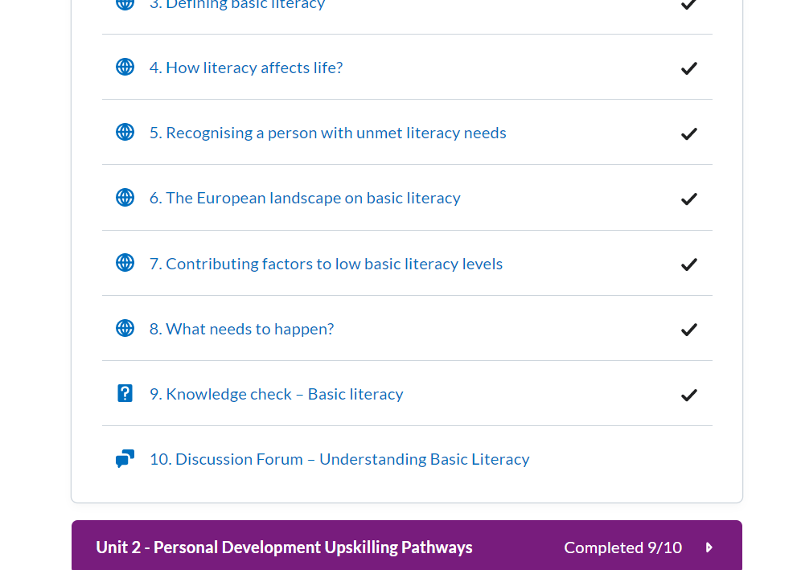

# How to use discussion forums

Click on the Discussion topic and **start a new thread** to edit

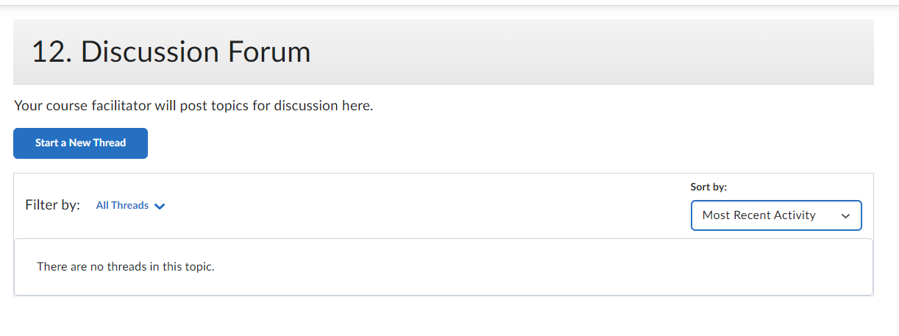

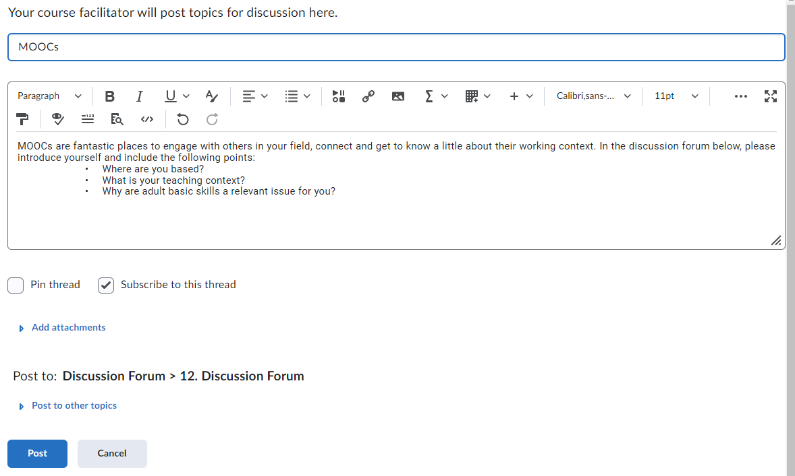

Click **‘post’** to create the topic

# Badges:

Learners will get a Digital badge if they post in each discussion forum. They can either reply to a thread or start their own thread.

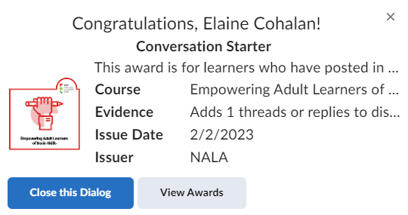

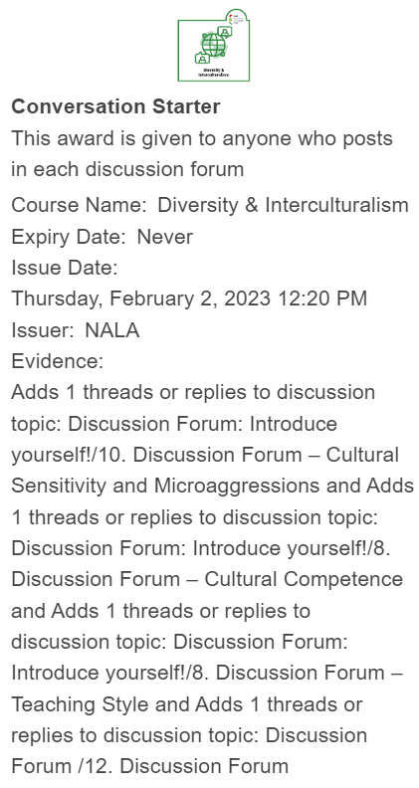

# Possible Issues with Discussion Forums:

As mentioned it above. It is suggested that you only edit the Discussion Forums through the “Content” button and not through Discussions  on the Navbar.

### Hidden Discussion Forums

Discussion forums can be hidden by going to “Discussions” in the Navbar. It is not recommended that you do this. If the Discussion forum isn’t visible it will say “hidden” beneath it. You can make it visible by selecting “Make visible to users”.

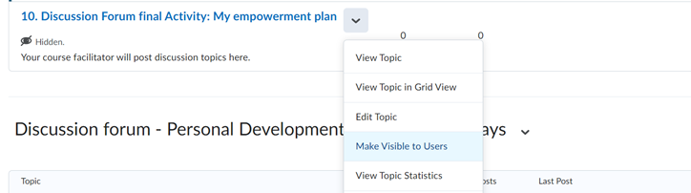

Unit 1:

# 2. Discussion Forum – Spark: The Adult Educator’s Many Roles

Note: this discussion forum has already been edited by NALA to match the supplied picture but please feel free to change as you see fit.



Discussion Forum: The Ideal Adult Educator

At times it feels like an educator must have 8 arms! Would you agree? In the discussion forum on the next page include your thoughts on the following question inspired by the above picture:

# 11. Discussion Forum – Spark: The Adult Educator’s Many Roles

Topics suggested for discussion:

1. MOOCs are fantastic places to engage with others in your field, connect and get to know a little about their working context. In the discussion forum below, please introduce yourself and include the following points:

• Where are you based?

• What is your teaching context?

• Why are adult basic skills a relevant issue for you?

2. Having been through the information on preparing learning materials as part of the facilitation process, please comment on some aspects of this topic that are important to you.

Please also ensure you comment on at least 2 of your peers’ submissions

3. Introduction of participants and their adult learning experiences. What are the composite elements of facilitation in adult learning? What can I recognize from them in my own learning/teaching practice?

Unit 2:

# 2. Spark - Aspects of Learner Differences

Note: this discussion forum has already been edited by NALA to match the supplied picture but please feel free to change as you see fit.

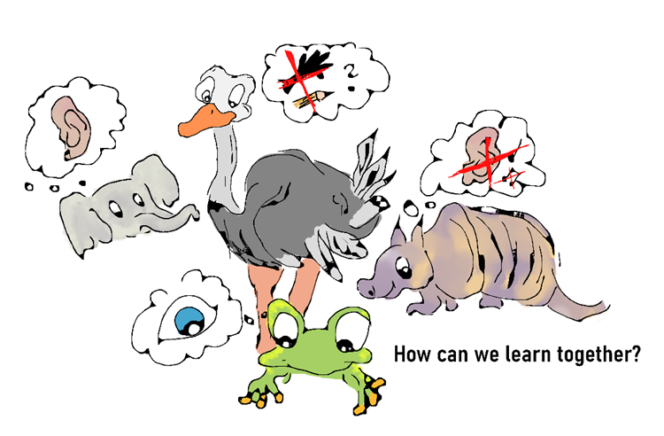

When we are learning in a group, (especially in an adult learning environment) will be an important question:

**“how can our personal characteristics influence the learning activities in the group?”**

**Discussion forum**

What do you think which learner characteristics and learning styles are truly important (and which not) for making learning more effective and efficient in adult learning in a group?

# 11. Discussion Forum - Strategies of Effective Facilitation in Adult Learning

Topics suggested for discussion:

1. Based on the content within this unit, is there a characteristic that is prioritized in adult education?
2. Who is a good adult learning facilitator in the scope of choices and limitations?

Unit 3:

# Spark: Useful Techniques for Facilitation

Note: this discussion forum has already been edited by NALA to match the supplied picture but please feel free to change as you see fit.



When we are teaching we can consider many useful techniques which can be helpful in the classroom. The active learning method is one of these techniques.

Have you heard about active learning before? Have you used it as a teaching approach? How did it work? Please tell us about your experiences from your teaching practice!

Now, take a look at the video below [6:53] <https://www.youtube.com/embed/xxVxgQJwV7w>

# 12. Discussion Forum – Understanding Basic Literacy

Topics suggested for discussion:

1. Name 3 issues of active learning approaches you can identify based on the cases in the readings and on the best practise description.

-They can be limitations, risks, opportunities, consideration of goals and learner groups, or any other aspect you find important.

2. Explain the significance of the chosen issues The best explanation is when you can attach it to your specific experiences and to particular adult learning situations.

Unit 4:

# 2. Spark: Can you see the big picture?

Note: this discussion forum has already been edited by NALA to match the supplied photo but please feel free to change as you see fit.

**

By the end of the last week of the course, how do you feel, did you manage to understand what to pay attention to when facilitating adults? Think about it. Do you know or have you ever heard of what regulations and best practices exist on the subject?

# 10. Discussion Forum – Common Concerns for Facilitators



Topics suggested for discussion:

Submit your template here and comment on at least 2 peers’ contributions.